Website:

“CARE”



Online Post Office Management System

# PROJECT GROUP MEMBERS

|  |  |
| --- | --- |
| **Students Id** | **Student Name** |
| **Student1417959** | **Moiz Khan** |
| **Student1424628** | **Ifra Khan** |
| **Student1425119** | **Asad Afza** |
| **Student1424612** | **Hanzala Khan** |

**CURRICULUM BATCH**

**6740 2210B3**

# FACULTY

**Sir. Ebad Uddin Ahmed**

# CO-ORDINATOR

**MS. Munazzah**

Online Post Office Management System

**SCREEN SHOTS**

Online Post Office Management System

# Admin Signup & Login

User can create an account whether they will be customer, employee or head.

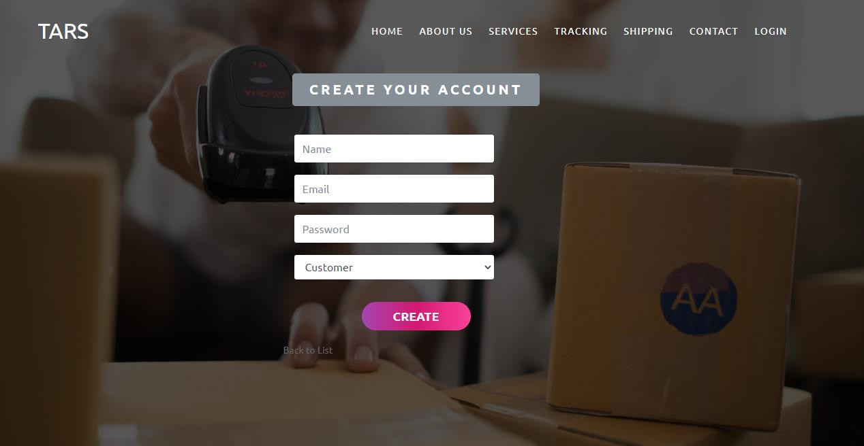

# Read Details

Employee and head can read the details of re

Users.

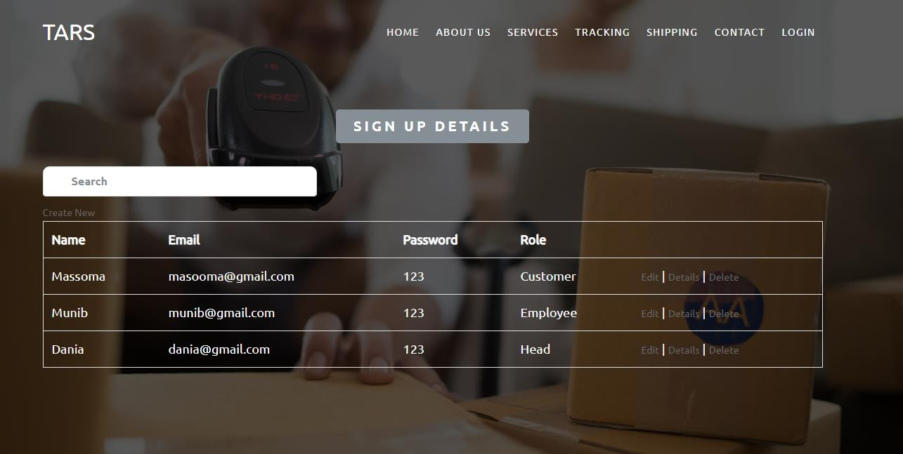

Online Post Office Management System

# Update Details

User can correct their information if they entered wrong information.

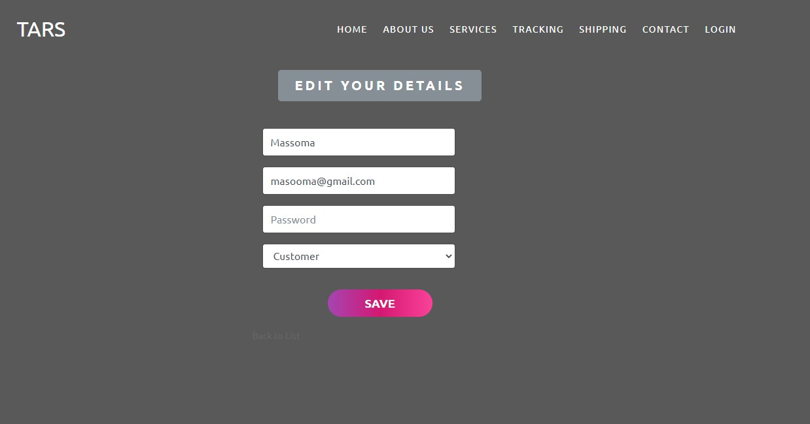

# Delete Details

Employee and head can delete inappropriate details

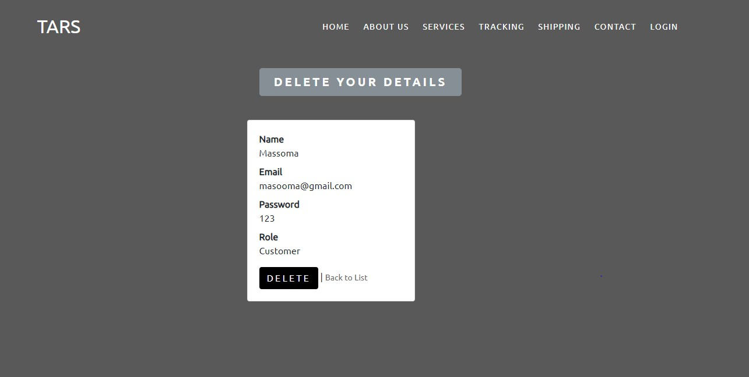

Online Post Office Management System

# Home Page Header

When user open our website, they will see this user- friendly home page.

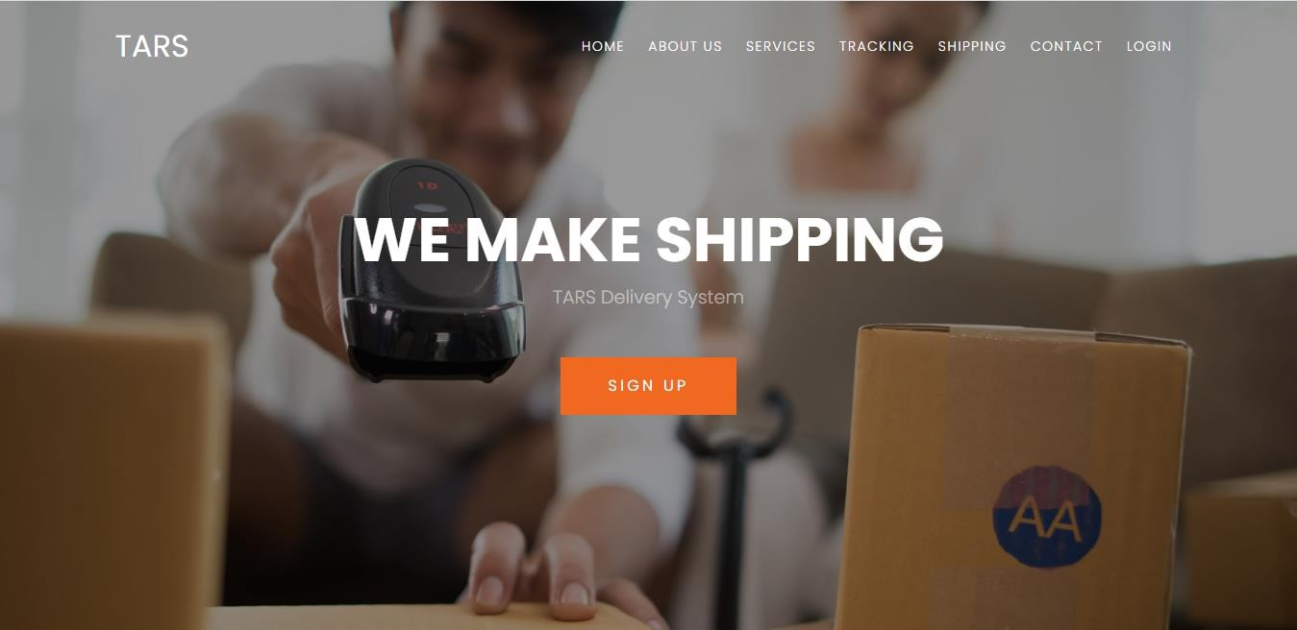

# Footer

In the end of the website user can see this footer which have some links.

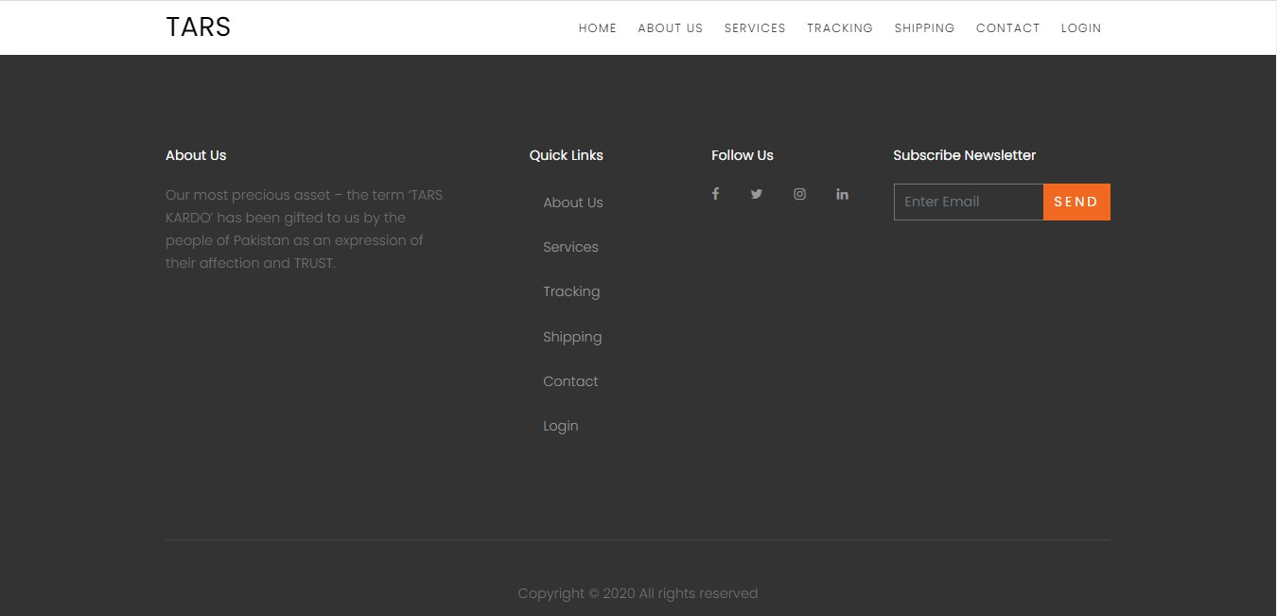

Online Post Office Management System

# Admin Profile

User can convert weight before placing order.

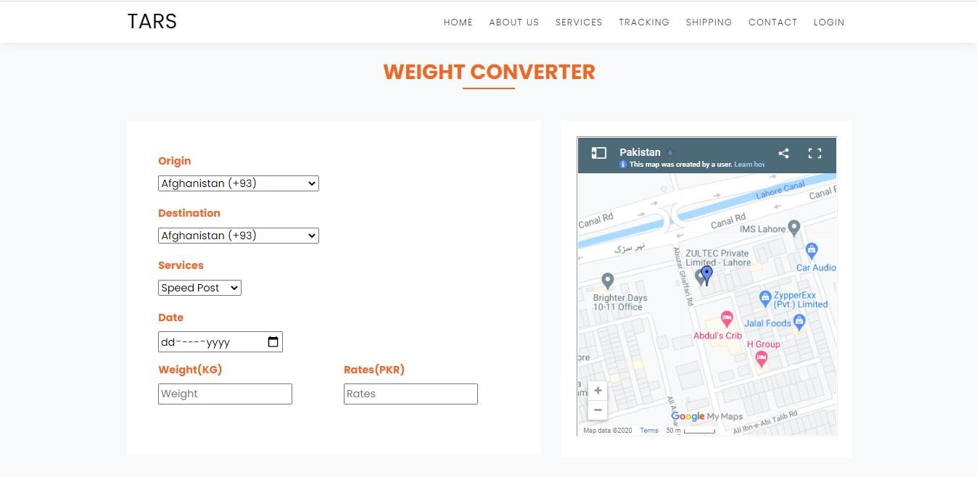

# Industries

Our home page can show user’s about or industries.

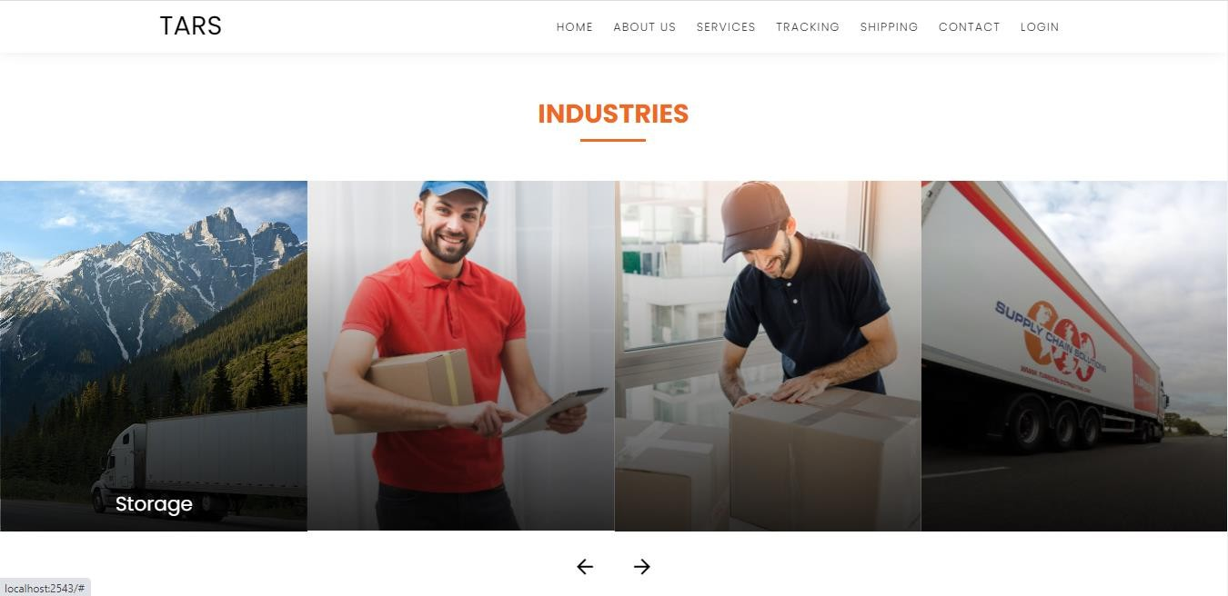

Online Post Office Management System

# About Us

About us shows some details of organization.



# Our Services

User can easily find our services.

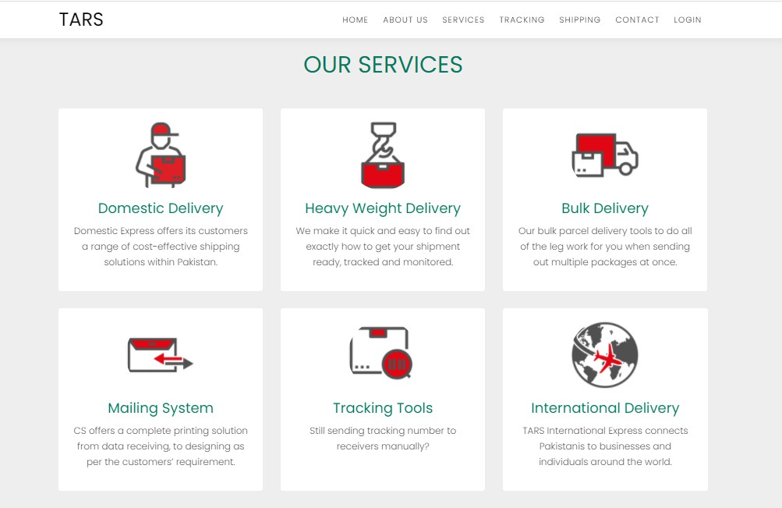

Online Post Office Management System

# Track Your Order

When user place an order then they will track their order easily.

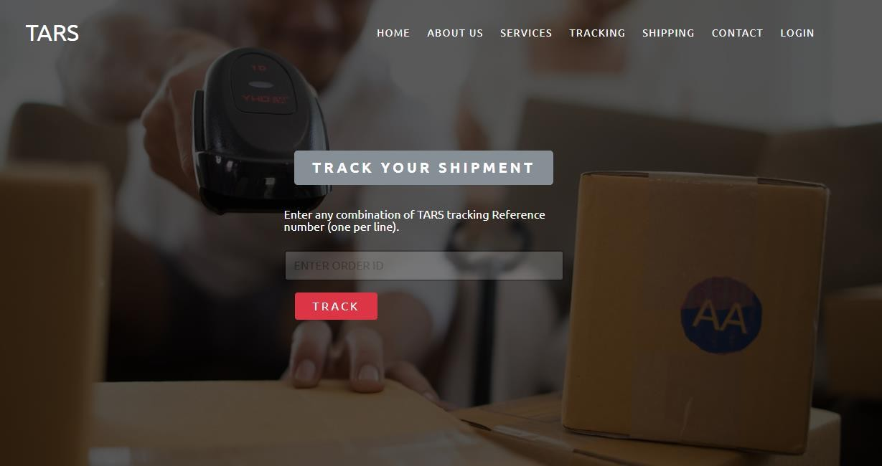

# Create A Shipment

User can create a shipment by register themselves and placing order.

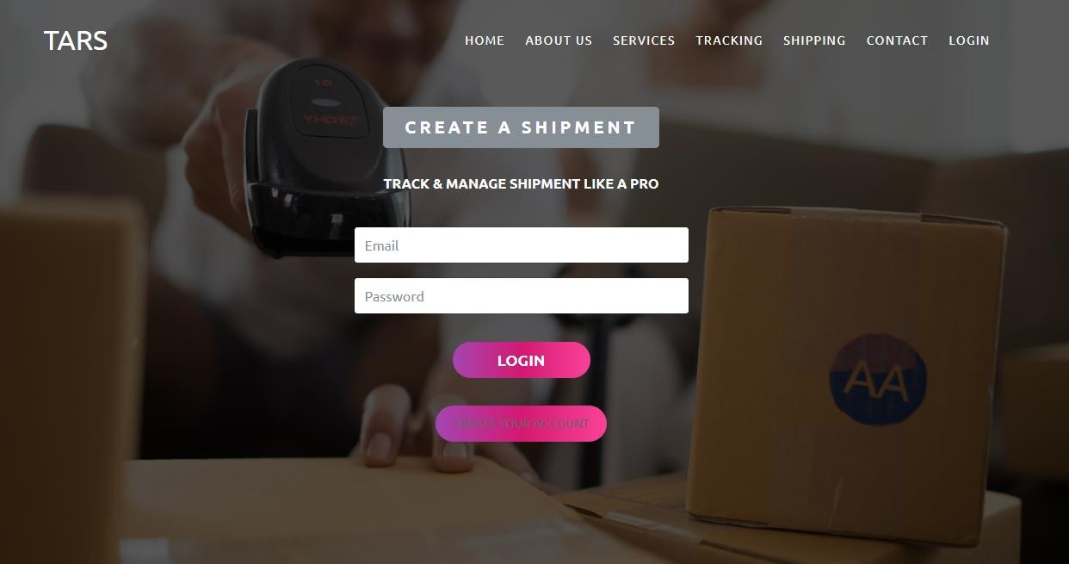

Online Post Office Management System

# Contact Us

User can contact if they had any issue in placing order.

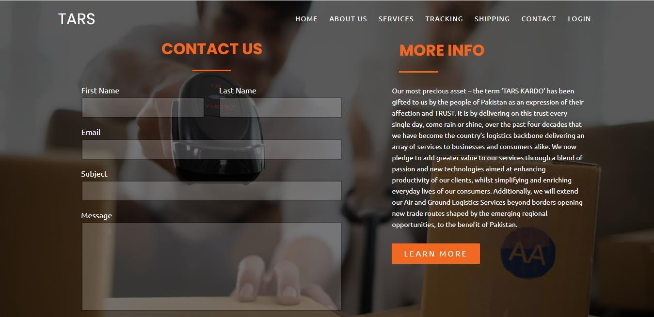

# Login

User can Login and register themselves.

